BTC·ETH·Gold High-Probability Structural Transitions # 26-2-15
1 BTC
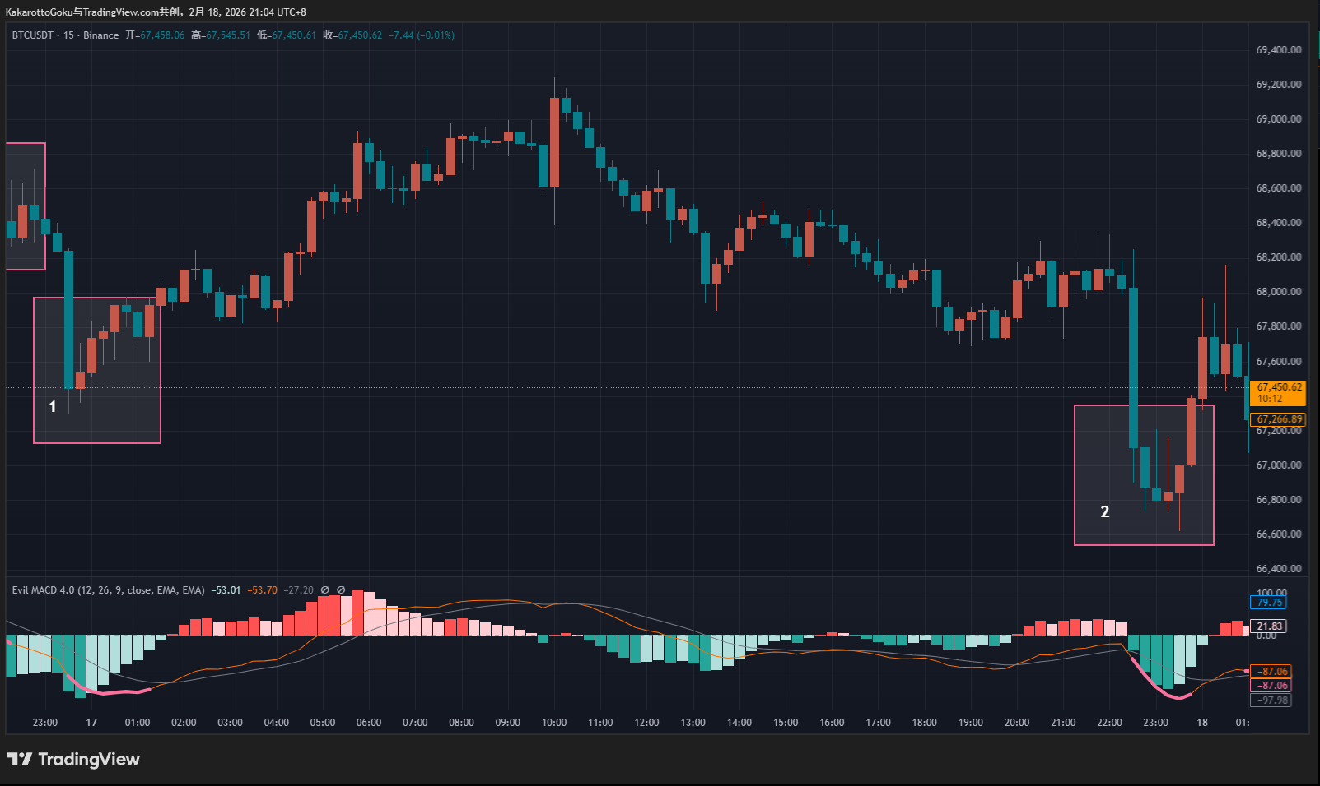
BTC 15-Minute Chart Analysis (2)
Today, BTC did not present a high-quality opportunity.
(Note: this conclusion is based on the 15-minute chart only. There may be opportunities on lower timeframes — we simply apply the same analytical logic.)
First, look at the unusual decline marked as position 1 on the chart. I call it “unusual” because of the sudden large bearish candle, followed immediately by a halt and rebound. The price action lacked rhythm and structure, making it impossible to draw a valid trendline.
However, as mentioned before, the absence of a trendline on the current timeframe does not mean one does not exist on a lower timeframe. The reversal structure here was likely hidden on the 5-minute or even 1-minute chart.
Later, we saw a very similar situation at position 2. Again, a sudden expansion in bearish momentum appeared in the form of a large candle, but it lasted only one bar before normalizing. Since no clear trendline could be drawn on the current timeframe, we could not apply trendline analysis. The structural reversal was very likely nested within a smaller timeframe.
2 ETH
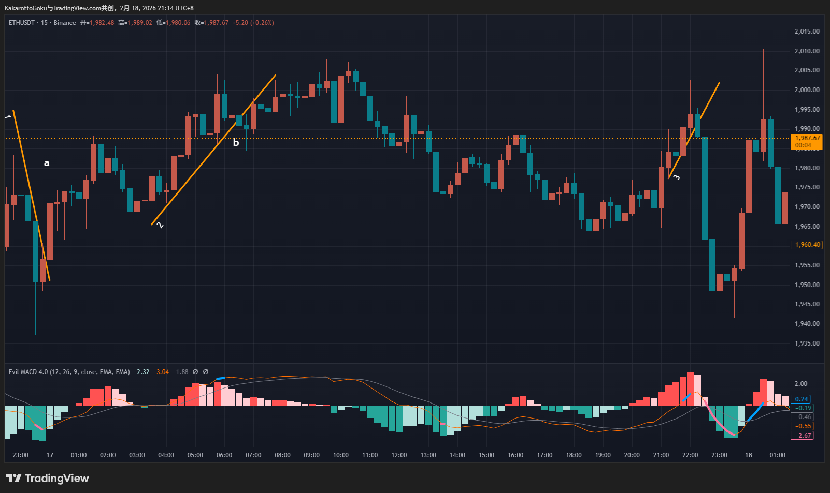
ETH 15-Minute Chart Analysis
ETH moved similarly to BTC overall, but with some important differences.
First, there was a downtrend followed by a pink bottom signal and a breakout at point A. Although the breakout candle had an upper wick, its length was less than 50% of the total candle range, which is still acceptable.
However, entering at A would require accepting a relatively large stop-loss range. Even though the trade eventually offered a profit opportunity, we cannot predict future price action in live trading. The potential stop-loss exposure must always be considered.
This is where trading style matters:
Conservative traders may choose to skip or use smaller size and leverage.
Aggressive traders may choose to participate.
Regardless of style, risk management must always come first. Before thinking about profit targets, we must clearly understand potential downside risk.
Next, we saw an upward trend (trendline 2) accompanied by a blue top signal and a breakdown at point B. The candle at B had a small body and small wicks, showing no strong bearish momentum. It was followed by a doji, indicating a state of indecision and buyer–seller balance.
This area was filled with uncertainty and best avoided. In fact, its certainty was even lower than at point A.
The highest-probability structural shift on ETH occurred at trendline 3.
Although the trendline was briefly broken by the low of a bullish candle, the penetration was minimal and price quickly reclaimed the level, meaning no real structural damage occurred. A blue top signal then appeared.
When trendline 3 was later broken downward, the breakout candle had a dominant body and very small wicks — almost negligible. Compared to A and B, this structural transition showed the highest level of confirmation and clarity.
3 Gold
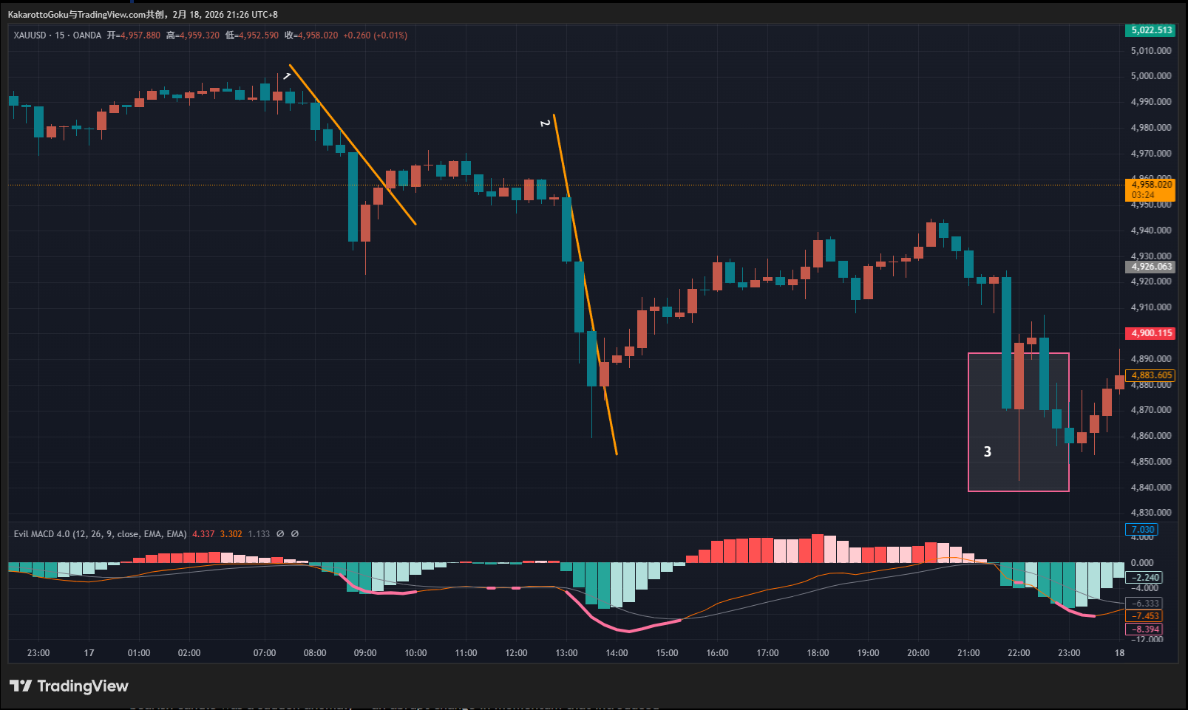
Gold (XAUUSD) 15-Minute Chart Analysis
Gold’s structure was particularly interesting.
Let’s compare trendline 1 and trendline 2.
At trendline 1, price initially formed small bearish candles, followed by a sudden large bearish candle, and then an immediate strong bullish recovery, forming a V-shaped reversal. That large bearish candle was a sudden anomaly — an abrupt change in momentum that introduced significant uncertainty.
Now compare that with trendline 2.
Although the bearish candles were still relatively large, their size was consistent and developed in alignment with the trendline. There was no sudden abnormal expansion. The movement progressed in a more structured and rhythmic way.
Even though the breakout upward had wicks dominating the candle body, the overall reversal amplitude was larger than at position 1.
This is precisely why I focus on structured, non-abrupt trend development — clean structures tend to provide higher certainty.
That said, both breakout positions at 1 and 2 were still better avoided.
Finally, we observed a region (area 3) where volatility expanded sharply. No valid trendline could be drawn, meaning trendline theory could not be applied in that zone.
Summary
From today’s review, we can see that not every reversal signal leads to a tradable opportunity.
By comparing:
- Trendline quality
- Candle momentum characteristics
- Structural development
we can identify which setups offer higher certainty.
When sudden volatility expansion occurs and structural confirmation becomes unclear, a more standard model is often hidden in a lower timeframe.
This resembles the concept of fractal structure in SMC-style analysis:
If a Break of Structure (BoS) appears on the current timeframe, a more refined and extreme BoS structure can often be found on a smaller timeframe.
The key is not to trade every signal — but to trade only clean structures with clear momentum confirmation.

